Voice of Community:  “The women were able to share their perspectives in a safe circle that they can trust. It became a real network circle for them. I can feel the spirit of empowerment there. Everyone felt they have something to say.” - Fairuziana  “Even from all our diverse backgrounds and experiences, we find it easy to sit down, woman to woman, and just talk to one another." - Susan  “PAIRWN saved my mother’s life! Thank you!” - Anonymous  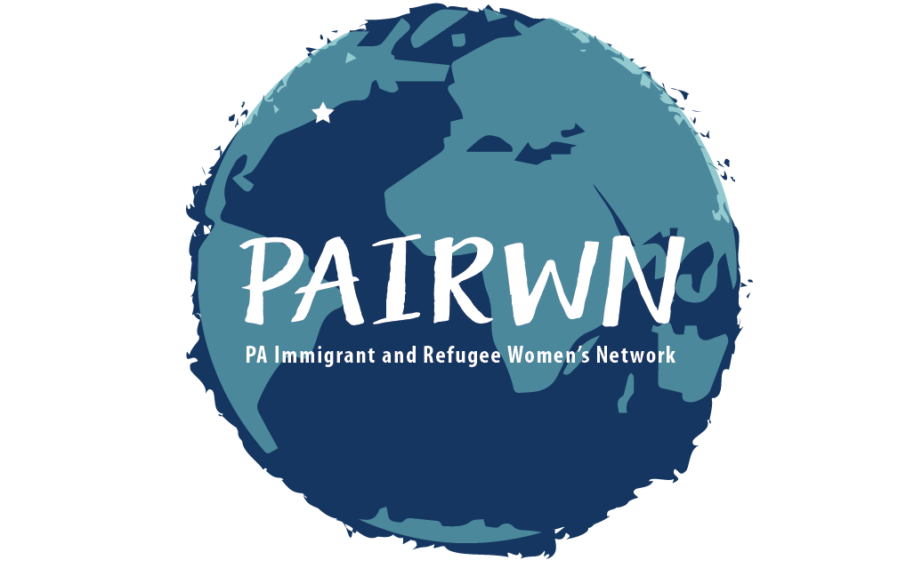  About PAIRWN:  PAIRWN was created in 2001 out of the need to bridge the gap between immigrant and refugee women and their communities. We are achieving our mission, one woman at time. |  |  | Know The Facts:  Domestic violence can happen to anyone.  - 38% of domestic violence victims  face homelessness.  - 35% of women worldwide  experience physical or sexual  abuse from intimate or non-intimate partners.  - Domestic violence is the leading  cause of death in women ages 15  to 44.  Sexual assault and stalking does not  discriminate. Yet, young women, minorities,  and women living with low incomes are more at  risk. No one deserves or asks for it!  If you have or are currently experiencing any of these issues, there is HOPE!  Contact Us:  717-980-3888  pairwn@pairwn.org  2101 N. Front St, Building 2, Harrisburg, PA 17110  Social support can decrease the negative symptoms,  and enhance daily functioning of the victim.  Contact  Contact Us  Phone: [Telephone]  Email: pairwn@pairwn.org  Web: pairwn.org  PAIRWN  2101 N. Front St., Building 2  Harrisburg PA 17110  Phone:  pairwn@pairwn.org  This project was supported by Grant No. 2017-VW-AX0015 awarded by the Office on Violence Against Women, U.S. Department of Justice. The opinions, findings, conclusions, and recommendations expressed in this publication/program/exhibition are those of the author(s) and do not necessarily reflect the views of the Department of Justice, Office on Violence Against Women. |  | Pennsylvania Immigrant and Refugee Women’s s Network  Pennsylvania  Immigrant and Refugee Women’s Network (PAIRWN)  Pennsylvania  Immigrant and Refugee Women’s Network (PAIRWN)  (PAIRWN)  Now Offering Free and Confidential Services for  Survivors of  Domestic Abuse, Sexual  Assault and Stalking  Celebrating a World of Differences and Bringing Women Together for Leadership and Fellowship

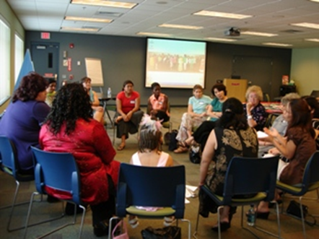  Did you know?  Immigrant and refugee women face more barriers when accessing social services for domestic violence, sexual assault, and stalking. With us, you are not alone.  FREE SERVICES WE OFFER:  1. Community Referrals -Transportation and accompaniment to Crisis Intervention, Housing, Legal Services, Counseling, Health Clinics, Food Pantries, English Language Classes, and many more.  2. Personalized Life Coaching  3. Story Circles  4. Empowerment Circles |  |  | About Our FREE Services:  Life Coaching—Experience one-on-one, woman-to-woman, support and guidance. Identify your values and goals, and let a fellow immigrant and refugee coach help you reach them. All sessions are confidential and free for survivors! We match you with a coach who understands your culture and language so you can focus on surviving and thriving. Interpretation and childcare is available.  Story Circles—Together we learn new information and skills, do arts and crafts, practice stress reduction techniques, exchange recipes and food, and network with each other, all while developing friendships, resources and support, and grow our network that lasts a lifetime. Open to all immigrant and refugee women.  Empowerment Circles—Share your personal stories of survival with a few other women who have experienced a similar situation. Learn what helped them, or share what helped you! Your story matters! For survivors only. |  |  | SAFETY FIRST  Each person has a right to dignity  and safety.  Have a safety plan but always call 911 if you are in immediate danger or are injured. Try to move away from rooms where everyday items can be used to hurt you (kitchen, garage). Get outside, if you can.  A spare bag of clothes, an extra set of keys, some money, and important documents for you and your children should be packed and at a friend’s house.  Suggested Documents:  - Social Security Card  - Immigration Paperwork  - Marriage Certificate  - Health Insurance Cards  - Financial Documents (Credit Cards, Checks)  Call the local hotline at the  YWCA of Harrisburg at  1-800-654-1211  Or the National Hotline at  1-800-799-7233  If you have a language barrier, ask for interpretation when you call and it will be provided.

